Assignment- 6-May-2022:

1. **What are the different types of storages? Explain with pros and cons**

#### **1. Simple Storage Service (S3)**

Amazon S3 is an object storage service that stores data of any type and size. It can store data for any business such as web applications, mobile applications, backup, archive, analytics. It also provides easy access control management for all your specific requirements and is almost 100% durable and by almost I mean 99.(11 nines)%. It can also be used to store all kinds of file formats as you would with a dropbox. S3 also allows a simple web-based file explorer to upload files, create folders or delete them.

#### ****Advantages of Object Storage****

There are many benefits associated with object storage including **scalability**. It’s widely known for its **compatibility with the cloud** and that’s because it has unlimited scalability. Because of its flat structure, object storage doesn’t have the same limitations as file or block storage.

Object storage has **faster data retrieval and better recovery** than other types of data storage. With object storage, there’s no need sift through file structures which means faster retrievals. The metadata allows for quick access and fewer limitations.

Lastly, **object storage is known for being cost-effective**. Because object storage scales out much easier than other storage types, it’s **less costly to store all your data**.

#### ****Disadvantages of Object Storage****

Are there disadvantages to object storage? Yes, object storage isn’t right for every use case when it comes to data storage. In fact, **you can’t use object storage for traditional databases**. It’s only great for static data.

#### **2. Elastic File System (EFS)**

EFS is a managed network file system that is easy to set up right from the amazon console or CLI. When you have multiple EC2 instances needed to access the same file system EFS helps in providing just that. Unlike EBS, EFS is built using the NFS4.x protocol on SSDs and have a much faster throughput. This also means that EFS is much more expensive than EBS as it can be used on very large analytical workloads. EFS scales up or down based on the size of the files you store and is also accessible from multiple availability zones. The distributed nature of the file system can tempt you to use it as a CDN. But the costs of a CDN outweigh the benefits of using EFS. Hence it is better to use a CDN and use EFS in conjunction with files that can’t be stored on a CDN.

#### **3. Elastic Block Storage (EBS)**

EBS provides block storage which is similar to hard drives to store any kind of data persistently. This can be attached to any EC2 instance and used as block storage, which even allows you to install any operating system. EBS volumes are placed in availability zones so that they are replicated to prevent loss of data due to single component failures. They provide absolute low-latency performance and you can also scale up or down your resources as and when required. EBS is available in both SSD and HDD formats depending on your requirement of speed and volume.

#### ****Advantages of Block Storage****

There are many benefits associated with block storage. First, their **numerous programming languages can easily read and write files** on block storage. Also, permissions and access controls for block storage are familiar and well-understood. Lastly, **block storage provides low latency IO** so they can be used with databases and dynamic data.

#### ****Disadvantages of Block Storage****

There are also several **disadvantages of block storage**. Block storage is limited to one server at a time which impacts scalability. Further, blocks and filesystems have limited metadata about the information they're storing such as creation date, owner, size and more. Another major disadvantage of block storage is the cost structure. With block storage, you must pay for all of the block storage space you have allocated even if you are not using it.

1. **What is EBS?**

An Amazon EBS volume is a durable, block-level storage device that you can attach to your instances. After you attach a volume to an instance, you can use it as you would use a physical hard drive. EBS volumes are flexible. For current-generation volumes attached to current-generation instance types, you can dynamically increase size, modify the provisioned IOPS capacity, and change volume type on live production volumes.

You can use EBS volumes as primary storage for data that requires frequent updates, such as the system drive for an instance or storage for a database application. You can also use them for throughput-intensive applications that perform continuous disk scans. EBS volumes persist independently from the running life of an EC2 instance.

You can attach multiple EBS volumes to a single instance. The volume and instance must be in the same Availability Zone. Depending on the volume and instance types, you can use [Multi-Attach](https://docs.aws.amazon.com/AWSEC2/latest/UserGuide/ebs-volumes-multi.html) to mount a volume to multiple instances at the same time.

Amazon EBS provides the following volume types: General Purpose SSD (gp2 and gp3), Provisioned IOPS SSD (io1 and io2), Throughput Optimized HDD (st1), Cold HDD (sc1), and Magnetic (standard). They differ in performance characteristics and price, allowing you to tailor your storage performance and cost to the needs of your applications. For more information, see [Amazon EBS volume types](https://docs.aws.amazon.com/AWSEC2/latest/UserGuide/ebs-volume-types.html).

3**. Write the Hands-On steps for creating a volume, attaching it and detaching it.**

**Steps to creating a volume:**

Click on create volume.

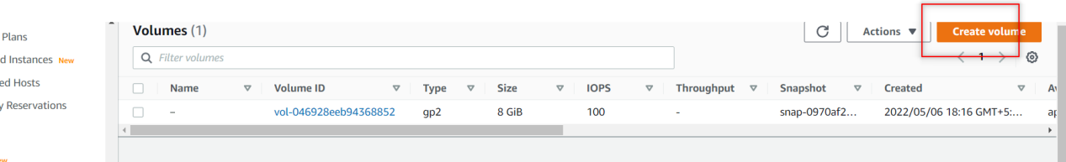

Keep as it the volume type and choose the availability zone that you need to create the volume , the volumes that are create from here are non- root volumes I.e extra volumes and click on create volume..

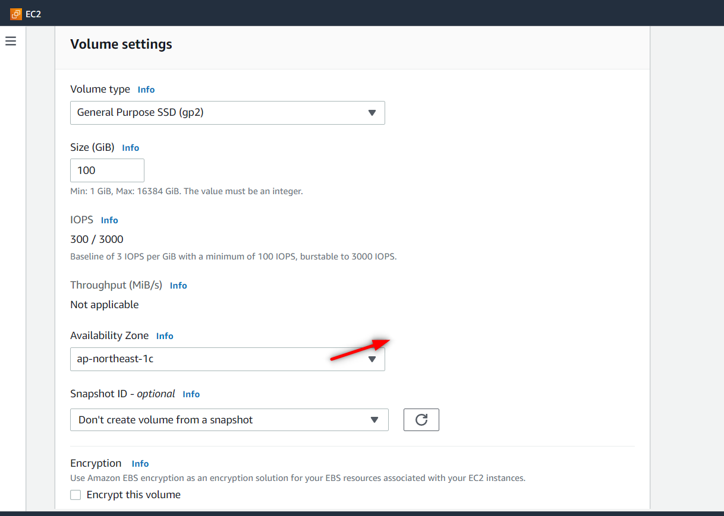

See the new volume has been created.

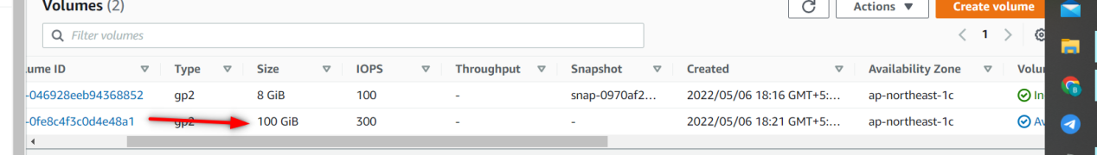

**Steps to Attach the volume:**

Click on the actions button there u will find option called Attach volume , click on that.

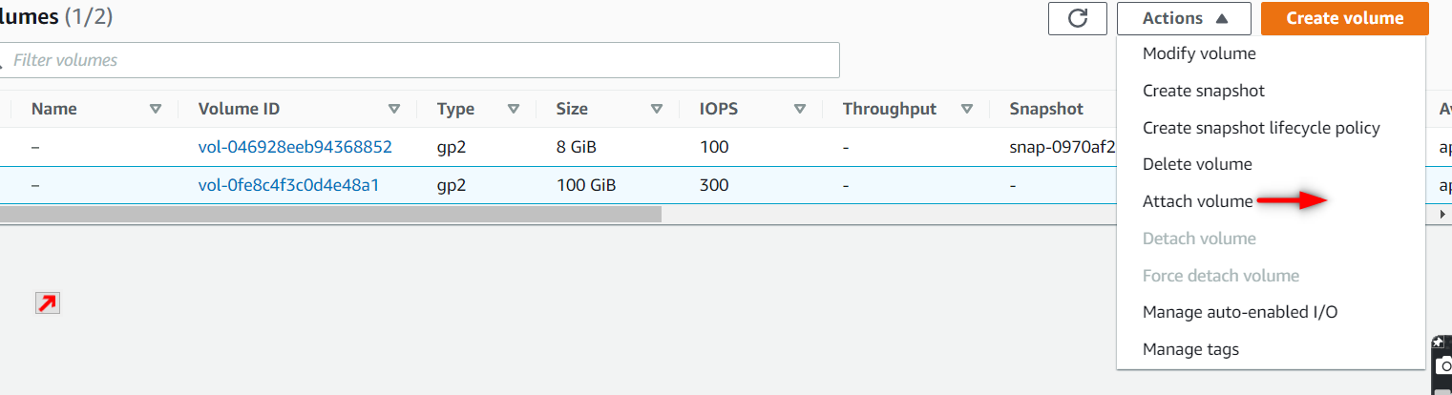

To attach a volume u have to provide the instance id where u want to attach and the volume can be attach in the same region that u have created the instance.and later click on attach volume.

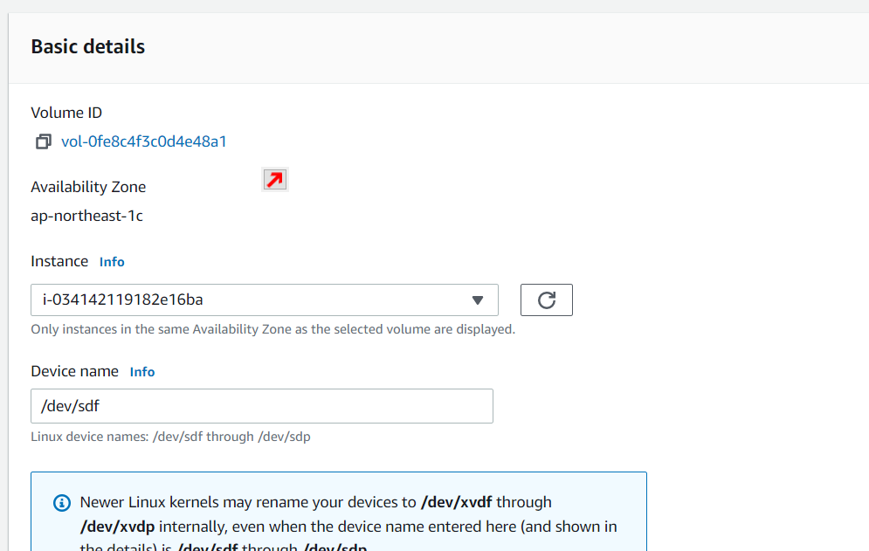

Now we can see that the volume got attached.

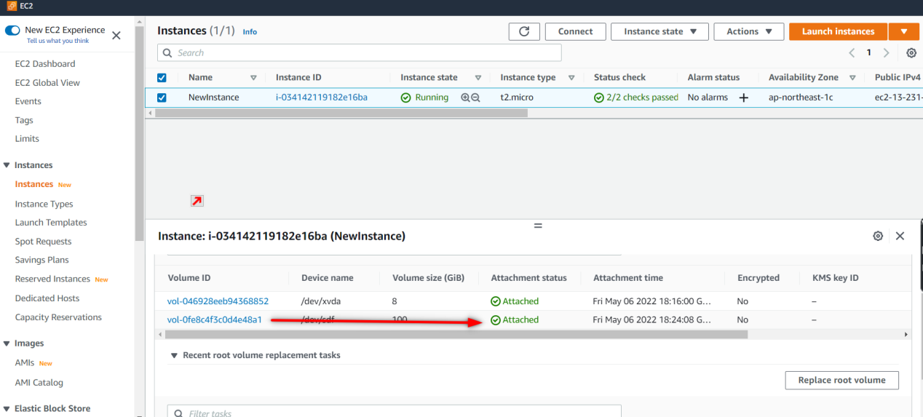

**Steps to Detach and Delete the volume:**

To detach the volume again click on actions button there u can find Detach volume , click that volume get detached.

To delete the volume same click on attach button and delete the volume.

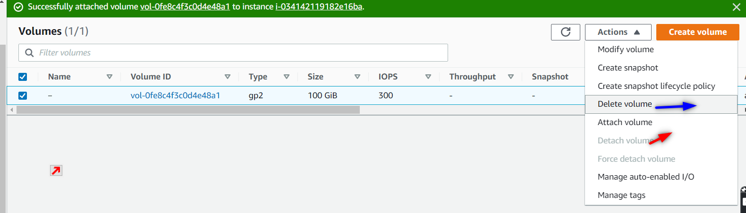

See once the volume get deleted , we can see this.

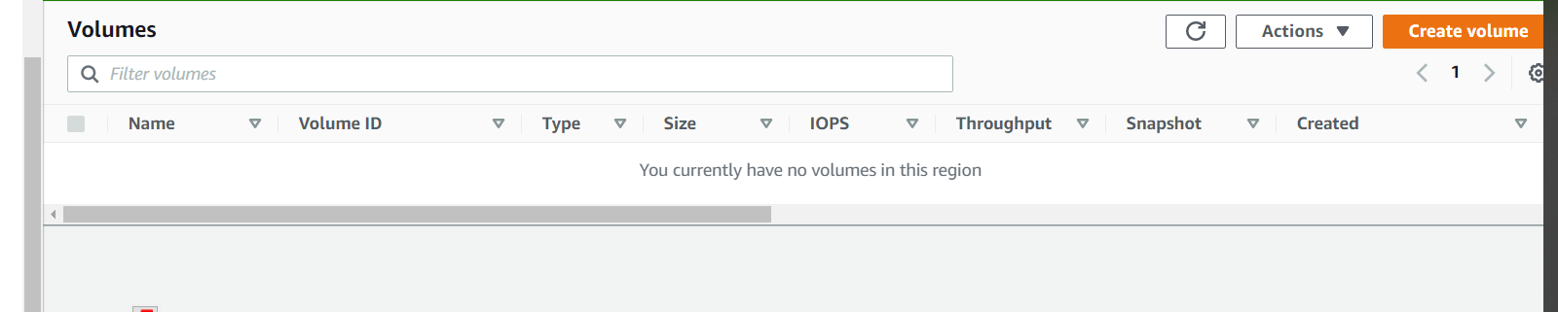

**4.What is a snapshot?**

Snapshots can be used to create a backup of critical workloads, such as large database or file system that spans across multiple EBS volumes. Multiple-snapshots allow you to take extra point-in-time ,data co-ordinate d and crash consistent snapshots across multiple EBS volumes attach to an EC2 instance.

Or

EBS Snapshots are **a point-in-time copy of your data**, and can be used to enable disaster recovery, migrate data across regions and accounts, and improve backup compliance. You can create and manage your EBS Snapshots through the AWS Management Console, AWS Command Line Interface (CLI), or the AWS SDKs.

**5. Write the steps with screen shots to create a snapshot and delete a snapshot.**

Under Elastic block store we have a option snapshots. And click on create snapshot.

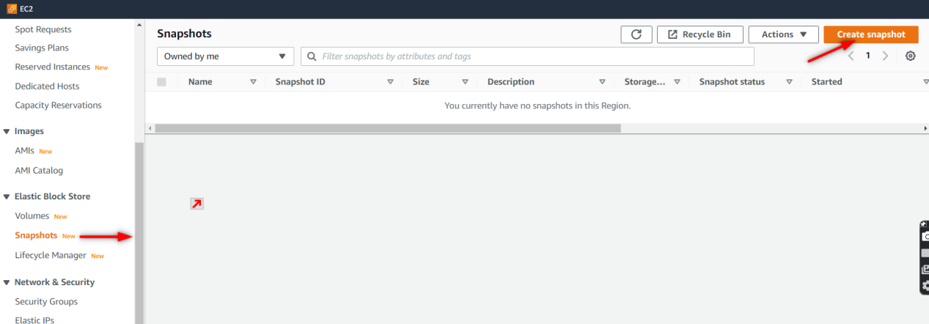

U have to provide the instance / volume id to create the snapshot and provide some description.

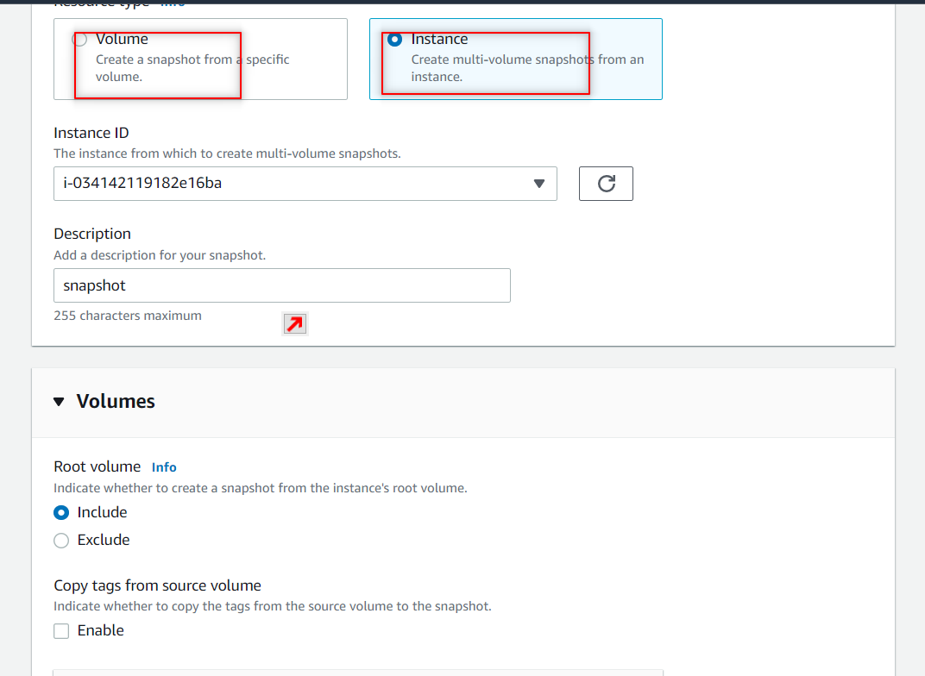

Click on create snapshot.

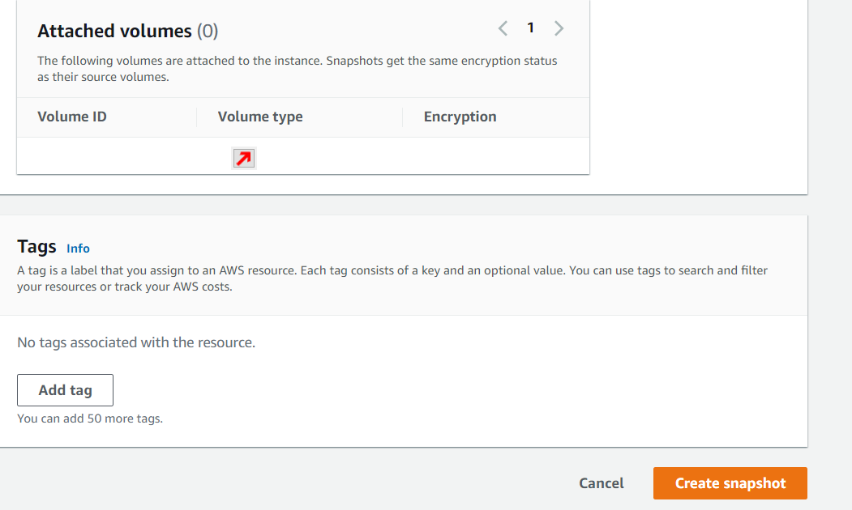

Here u can see that the new snapshot got cretaed.

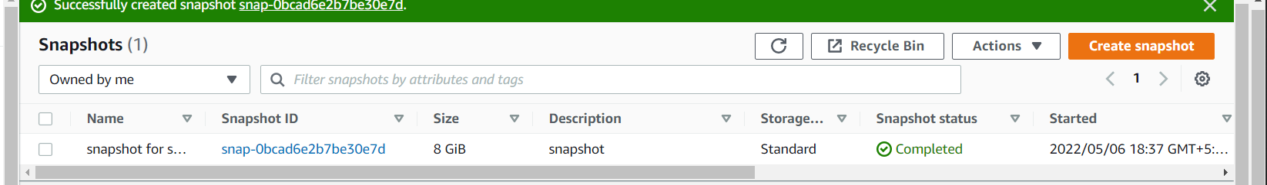

To delete the snapshot click on Actions button and there u find delete snapshot click that the snapshot get deleted.

